Math 1211 Discussion assignment 2
In the discussion forum, you are expected to participate often and engage in deep levels of discourse. Please post your initial response by Sunday evening and continue to participate throughout the unit. You are required to post an initial response to the question/issue presented in the Forum and then respond to at least 3 of your classmates’ initial posts. You should also respond to anyone who has responded to you.
Discussion prompt:
If an n-sided regular polygon is inscribed in a circle of radius r, as shown in the figure below, then n-isosceles triangles fill the circle.
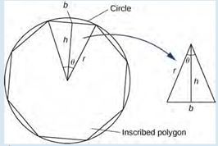
Based on the statement and figure above answer the following:
1. Express h and the base b of the isosceles triangle shown in terms of θ and r.
2. Express the area of the isosceles triangle in terms of θ and r. Use trig identities as needed.
3. Describe what happens as n goes to infinity, (notice the polygon fills the circle, the angle θ goes to zero)
4. Use special limit rules to discuss your response, you may use any graphing tool to support your response.
Your Discussion should be a minimum of 250 words in length and not more than 450 words. Please include a word count. Following the APA standard, use references and in-text citations for the textbook and any other sources.
- According to (2.3 The Limit Laws - Calculus Volume 1 | OpenStax, n.d.),
By the definition of trigonometric cos = h/r, and sin = (b/2)/r, thus

h = *
b= 2 * r
- The Area of isosceles triangle formular is
S = ½ x height x base (Area of Isosceles Triangle (Formulas, Derivation and Examples), n.d.)

Thus, the area of the isosceles triangle can be expressed as
height = *
base = 2 * r
the area is S = ½ x * x 2 * r = ( ) * r²
- Now we need to consider the situation where the polygon getting divided into smaller triangles.
We need to get the area when approaches to 0.
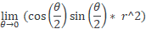
According to the product law of limits (2.3 The Limit Laws - Calculus Volume 1 | OpenStax, n.d.),

When r not equal to 1,
= 1
= 0

Thus
= 0

= 0

- Using the graphing tool, we can draft the below picture,
we found that the function having a continuous intercept at the position of (0,0)
this observation is matching our result of the limit .
f(x)= ((sin(((x)/(2)))cos(((x)/(2))))/(r^(2)))
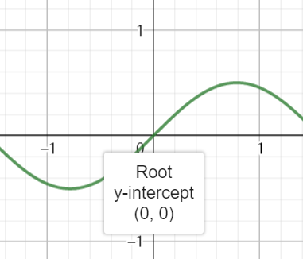
According to (2.3 The Limit Laws - Calculus Volume 1 | OpenStax, n.d.), the special limit rule, the limit of the constant is still the constant.
So * R² = R² * = R² * 0 * 1 = 0

Reference
2.3 The Limit Laws - Calculus Volume 1 | OpenStax. (n.d.). Retrieved September 11, 2022, from https://openstax.org/books/calculus-volume-1/pages/2-3-the-limit-laws
Area of Isosceles Triangle (Formulas, Derivation and Examples). (n.d.). Retrieved September 11, 2022, from https://byjus.com/maths/area-of-isosceles-triangle/

